2016 Pink Shirt Design TEAM Contest!
Entry form for Managers/Supervisors
Please submit entry form (one per team) to: EmployeeEngagementInquiries@vch.ca OR via interoffice mail to: Employee Engagement, 601 W Broadway - 10th Floor - C/O Nina Paauwe
Win a pop-up party for your team!
Feb 24, 2016 is Pink Shirt (Anti-Bullying) Day! Share what respect means to you and your team for a chance to win a pink pop-up party for your team (treats and door prizes delivered to your area) and exclusive 2016 pink t-shirts for your entire team! Hint: be specific and respectfully creative! Contest closes January 16, 2016. Please complete all required fields below:
Manager/Supervisor Name:
Submitted by:
VCH Email Address:
Unit/department and site:
Senior Executive/COO:
To our team, respect means (max one sentence):
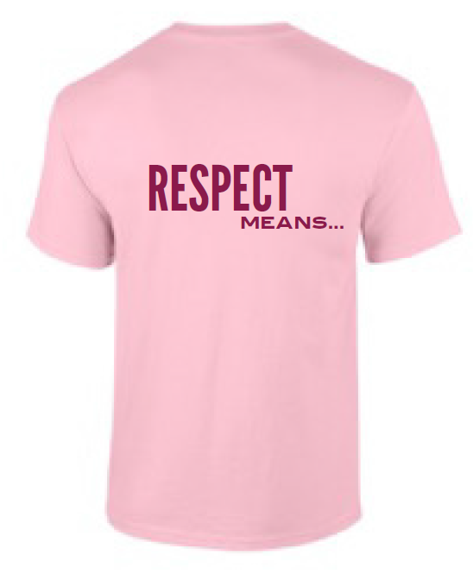
*Feel free to include supporting material with your submission (photos, quotes, story etc.) that shows the importance of team respect! Each Senior Executive Team (SET) member will select and summarize one statement to be included on the 2016 VCH pink t-shirt design….
If you have any questions, please email Esther Eidse, HR Advisor Lead, at Esther.Eidse@vch.ca.
Thanks for participating!

